**LAB 5 –** Eli Sobylak

**PART I:**

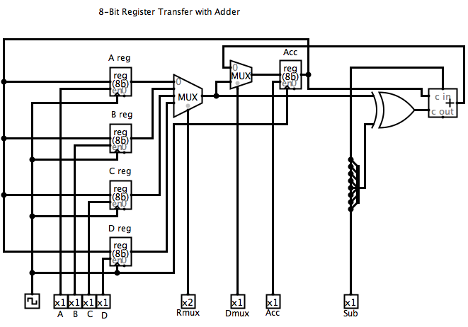

Control Code

ABCD Rmux Dmux Acc Sub

4-bits 2-bits 1-bit 1-bit 1-bit

Total = 9 control bits

**PART II:**

1. Areg ➔Acc

2. Add Breg to Acc ➔Mem(Acc)

3. Subtract C from Acc ➔ Mem(Acc)

4. Add Dreg to Acc ➔Mem(Acc)

Control codes:

1. ABCD Rmux Dmux Acc Sub

0000 00 1 1 0

2. ABCD Rmux Dmux Acc Sub

0000 01 0 1 0

3. ABCD Rmux Dmux Acc Sub

0000 10 0 1 1

4. ABCD Rmux Dmux Acc Sub

0000 11 0 1 0

0x13 to decimal: 19

0x5b to decimal: 91

0x3a to decimal: 58

0xf0 to decimal: -16

The end value in Acc would be 0x24 which in decimal is 36.

An overflow did not occur during this process

The data flow is as follows;

1. Take value Areg and move to Acc

2. Add value in Breg to Acc and save in Acc

3. Subtract Creg from Acc and store in Acc

4. Add Dreg to Acc and store in Acc

5. Done

|  |  |  |  |  |  |  |  |
| --- | --- | --- | --- | --- | --- | --- | --- |
| **TIME** | **A-B-C-D** | **Rmux** | **Dmux** | **Acc** | **Sub** | **Action** | **Acc Value** |
| 0 | 13-5b-3a-f0 | 00 | 0 | 0 | 0 | - | 00 |
| 1 | 13-5b-3a-f0 | 00 | 1 | 1 | 0 | Areg ➔Acc | 13 |
| 2 | 13-5b-3a-f0 | 01 | 0 | 1 | 0 | Add Breg to Acc ➔Mem(Acc) | 6e |
| 3 | 13-5b-3a-f0 | 10 | 0 | 1 | 1 | Subtract C from Acc ➔ Mem(Acc) | 34 |
| 4 | 13-5b-3a-f0 | 11 | 0 | 1 | 0 | Add Dreg to Acc ➔Mem(Acc) | 24 |

**PART III:**

Machine State Trace: